Sarantos Bio - 11 years and still getting away with it!😏

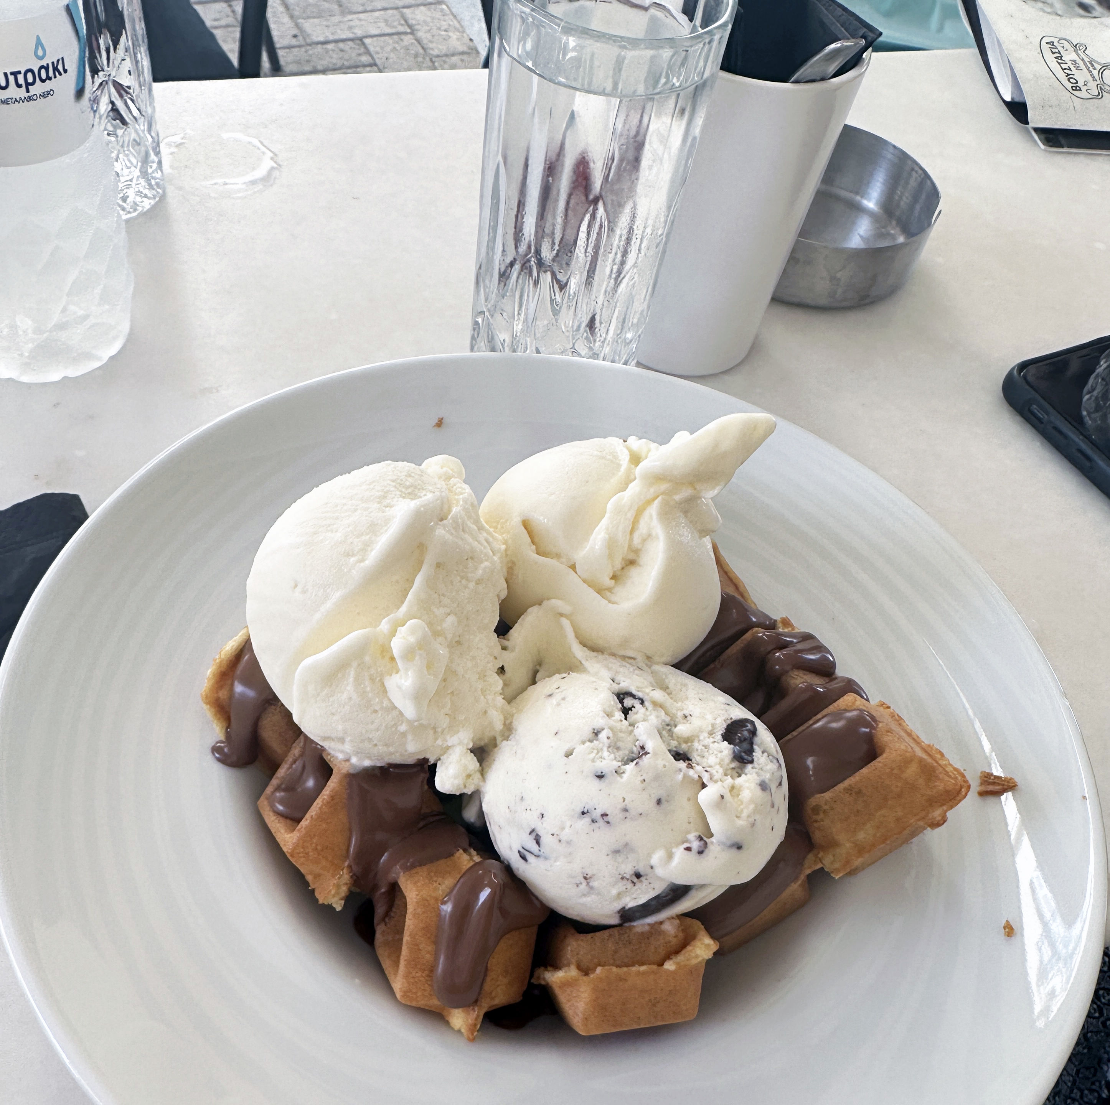
Who says nerds can’t make hit music?

Sarantos is a Chicago based nerd and retired superhero who always has a story to tell. He is a DIY international award-winning solo music artist, Top 7 iTunes UK Charting in the Rock Genre, Top 5 iTunes UK Singer-Songwriter, Top 8 iTunes UK Country, #1 iTunes South Africa Folk & Country, #1 iTunes UK Christian, #1 iTunes UK New Age, #2 iTunes UK World, and #30 iTunes UK Pop. He is a proud nerd, multi-instrumentalist, book author, comic book nut, radio show host, poet and part time spy. His vocals and songwriting are a cross between the Beatles, Ed Sheeran, Freddie Mercury, Justin Bieber and Steve Perry. Sarantos doesn’t even use a professional studio to make any of his music! He’s an alien who landed here to infect the human race and spread the disease of music. 2024 is Year #11 of his journey as he continues to release a new song, lyric video, music video, book chapter and poem every month bringing his music to life! In 10 years, he has released 20 albums with 249 original tracks as well as 10 fiction/fantasy books that parallel the songs! He has had numerous media placements for his songs, instrumentals & cues including several episodes of The Young & the Restless in 2021 and the list grows on and on.

Every year until the day he dies, every single month Sarantos will release a new song & lyric video in week 1, new music video in week 2, new book chapter in week 3, and a new Poem in week 4. The CD & complete book will then be released every November along with a surprise Instrumental CD every year. Forever.

His art is for all the nerds, loners or misunderstood souls out there (or anyone like him who wasn’t allowed to hang out with the popular people in high school). By the way, he has no idea how famous he is now. His music, books and poems are 100% certified organic, caffeine independent, gluten free and hypoallergenic!

Sarantos unique sound is described by industry insiders as "an emotionally powerful style masterfully united with a fusion of 80s rock blended with modern pop rock music!" He tackles almost every genre imaginable expanding his unique signature style with an eclectic mix of edgy experimentation. Fans enjoy regular surprises and are always left wondering what’s next. He’s looking for fans who want to go where he wants to take them.

Because he believes that every song is a story and words are so important to him, he hosts the Songwriters Show which is broadcast live on #1 ranked Reality Radio with listeners in all 206 countries in the world and every state in the US. The station is licensed with ASCAP, BMI, SESAC, and Sound Exchange with partnerships throughout the music industry including iHeartRadio with exposure to over 300 million listeners. The show is syndicated on over 60 channels including iHeartRadio, Spotify, Spreaker, iTunes, TuneIn, Stitcher, Alexa & Google Play.

In 2017, Sarantos had two songs submitted and accepted for consideration for a Grammy Award for
Rock Song of The Year & both songs made it to the final 300 and the last round of voting!
Sarantos has won 54 awards such as Golden Wheat Awards, Mumbai Shorts, Shenzhen International Film Festival, Paris Film Festival, Akademia LA Music Hall of Fame, Beat 100 etc while also being nominated many times in numerous categories for the International Music & Entertainment Awards, Hollywood Music In Media,
Josie Awards, Prayze Factor Awards, WAM Awards, Red Carpet Holland Awards, Hollywood Gold Awards, Webby Awards, Las Vegas Independent Film Festival, FICOCC, ALTFF and the Hollywood Songwriting Awards.

Even without backing from a studio, label, ad agency or radio promoters, his songs Above The Clouds, Dreamer, and What If I Never See You Again have spent many months in the top 200 on the majors list in the US for radio airplay according to the Digital Radio Tracker Top 200 charts. On the independent charts, Sarantos has hit the top 10 several times. He’s even been picked up on the BBC worldwide! His songs are broadcast on various radios stations around the globe daily.

Sarantos is not only a professional songwriter, producer & poet but also an avid comic book reader, proud nerd, workaholic, one-time owner of the Millennium Falcon, gamer and zombie killer. He loves sarcasm because it’s funny. He’s more of a loner than a social butterfly but he’s working on it. Sarantos prides himself on not releasing robotic music. When playing live, the music is authentic and real. It has imperfections because it is human. He is always trying to sound different musically, lyrically and vocally. His songs don’t all sound the same, and that’s on purpose! He doesn’t want fans or critics to get bored. Sarantos efforts stimulate an overdue conversation in the always-changing music industry.

“Sarantos is not your average songwriter and artist. In fact, he is a true musical powerhouse who embraces
a keen DIY edit. He is deeply connected to his music, and there is quite nothing that strikes as deeply
as an artist who seriously means what he focuses on with his music” – Band Camp Diaries

“Winning the hearts of worldwide listeners, emerging star Sarantos is spreading his creative aura!” – Daily Music

“Sarantos is possibly the most active singer-songwriter in the music industry right now. He’s someone who
performs how he wants, where he wants, and it gives him the freedom to showcase his creativity.” – Indie-Music

“His music is often described a blend of Queen, Michael Jackson and Ed Sheeran.” – Artist Central

“Sarantos is an internationally acclaimed independent artist who has the determination of a gazelle to
seek out each day with the strength of a lion to dominate the jungle.” – African Hype

“Leave it to Sarantos to find a voice for those who don’t seem to have one of their own.” – Honk Magazine

Read more reviews here: www.reverbnation.com/sarantosmelogia/press

Sarantos currently has over 1 million Social Media followers and has been consistently rated #1 on Reverbnation in the rock and even pop genre worldwide. Sarantos has performed at multiple venues including the Toronto Music Festival to a sold-out live audience.

Sarantos has been writing lyrics since 4th grade and is passionate about the words he puts to the music. Sarantos has written over 4,000 songs. He always had an abnormal fascination with music, much to the expense of a normal personality development. Sarantos lives for humor but also humility confessing he’s “made more mistakes than anyone else!”

He underwent many personal challenges including his father passing away in 2010 after a long hard-fought battle with lung cancer, dealing with personal health issues like asthma, chronic allergies, eosinophilic esophagitis with a stricture the size of a straw and a dairy food allergies, chronic neck and back pain, perfectionist tendencies and perpetual feelings of inadequacy.

Sarantos is a proud supporter of charities & donates directly to many charitable organizations!

Sarantos has always been inclined to help people in need and is proud to donate a portion of all proceeds to charity, hopefully inspiring other artists to do the same. His fans help him choose the charity each month for every song. A few of the charities chosen so far include the American Cancer Society, American Lung Association, Make-a-Wish Foundation, American Heart Association, St Jude's, American Red Cross, Salvation Army, Alcoholics Anonymous and many more.

You can’t buy happiness, but you can listen to Sarantos and that’s kind of the same thing

The website, Melogia (which in Greek means "with words") was established by Sarantos, an aspiring singer and song writer.

Sarantos Musical Mission:

When you listen to one of my songs, I want you to feel the need to:
- Sing
- Dance or move to the groove
- Play the song over and over again (HIT THE REPLAY BUTTON!)

Website: www.melogia.com
Email: info@melogia.com
Facebook: www.facebook.com/Sarantosmelogia
Twitter: www.twitter.com/sarantosmelogia
Youtube: www.youtube.com/user/SarantosMelogia
Instagram: www.instagram.com/sarantosmelogia
Tik Tok: https://www.tiktok.com/@sarantos
Apple Music: https://music.apple.com/us/artist/sarantos/784136489
Spotify: https://open.spotify.com/artist/0fSzbfDxSHL10T1ryPsRLQ

